**Web Applications Development Coursework**

**Name: Nikolaos Papadopoulos**

**Project Title: Moodhunter music site**

**Link: https://smcse.city.ac.uk/student/acwv103/projectweb/**

My website’s concept is based on types of music depending on the user’s mood, their past or future activity, the weather and music genre. Firstly, I started by drawing on paper how my Home page would look like, to start coding it from top to bottom. Separating the page in many divisions gives you a starting point on how I wanted the page to look like. Using HTML, CSS and especially JavaScript for the first time has been challenging, but practicing by using the material from the lab, W3schools and several online websites you get an idea about what, more or less, you are aiming at.

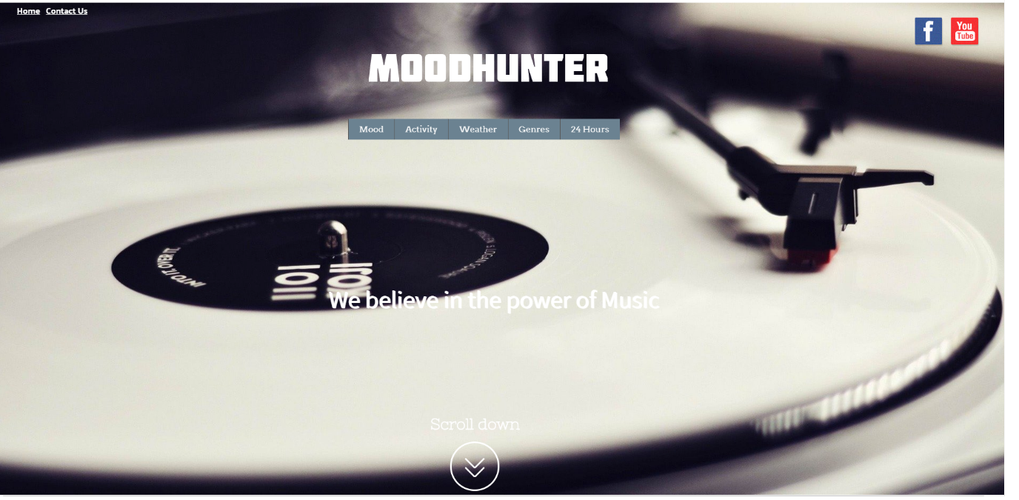

On the home page there is a carousel/slide show with awesome pictures that fade every 4 seconds and over those images you can see the navigation bar. Through the navigation bar the user can pick a playlist by clicking on it and it will take the user to the specific page. I wanted the navigation bar to be a dropdown menu while the cursor is hovering over it. Scrolling down there is a grid container with on-click pictures which does the same effect. So, depending on the user’s mood or activity one can listen to YouTube playlists which I picked out myself.

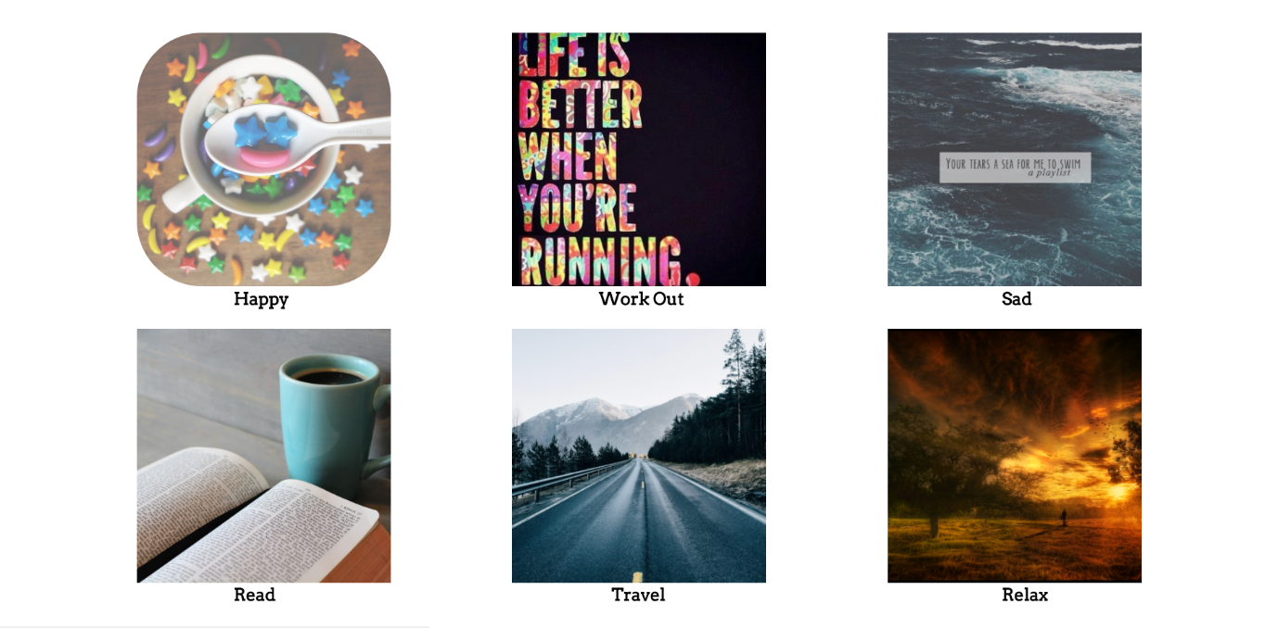

The main technologies which have been used on my website are HTML,CSS and JavaScript. For some specific functions, using JavaScript is essential to show animation and dynamic content. I tried using D3, but the coding was too complicated for me to apply. However, in the future I will do my best to learn more about it and apply it to the sites I will code.

Regarding the mistakes that were made, they were many, and some ideas that I would like to have implemented on the site were too difficult to code so I decided not to include them. For example, the fade effect on the text, into the grid items. When the user hovers over a grid item it should display the mood that the picture shows. So, instead of doing that I just placed the text under each grid item. Another issue on the home page was to adjust the scroll down arrow on top of the carousel and make it rotate 45 degrees each way. I also wanted to include a footer with the sitemap of the site but I did not have enough time to create one. Talking with colleagues and mainly googling for answers is how I overcame the difficulties I had.

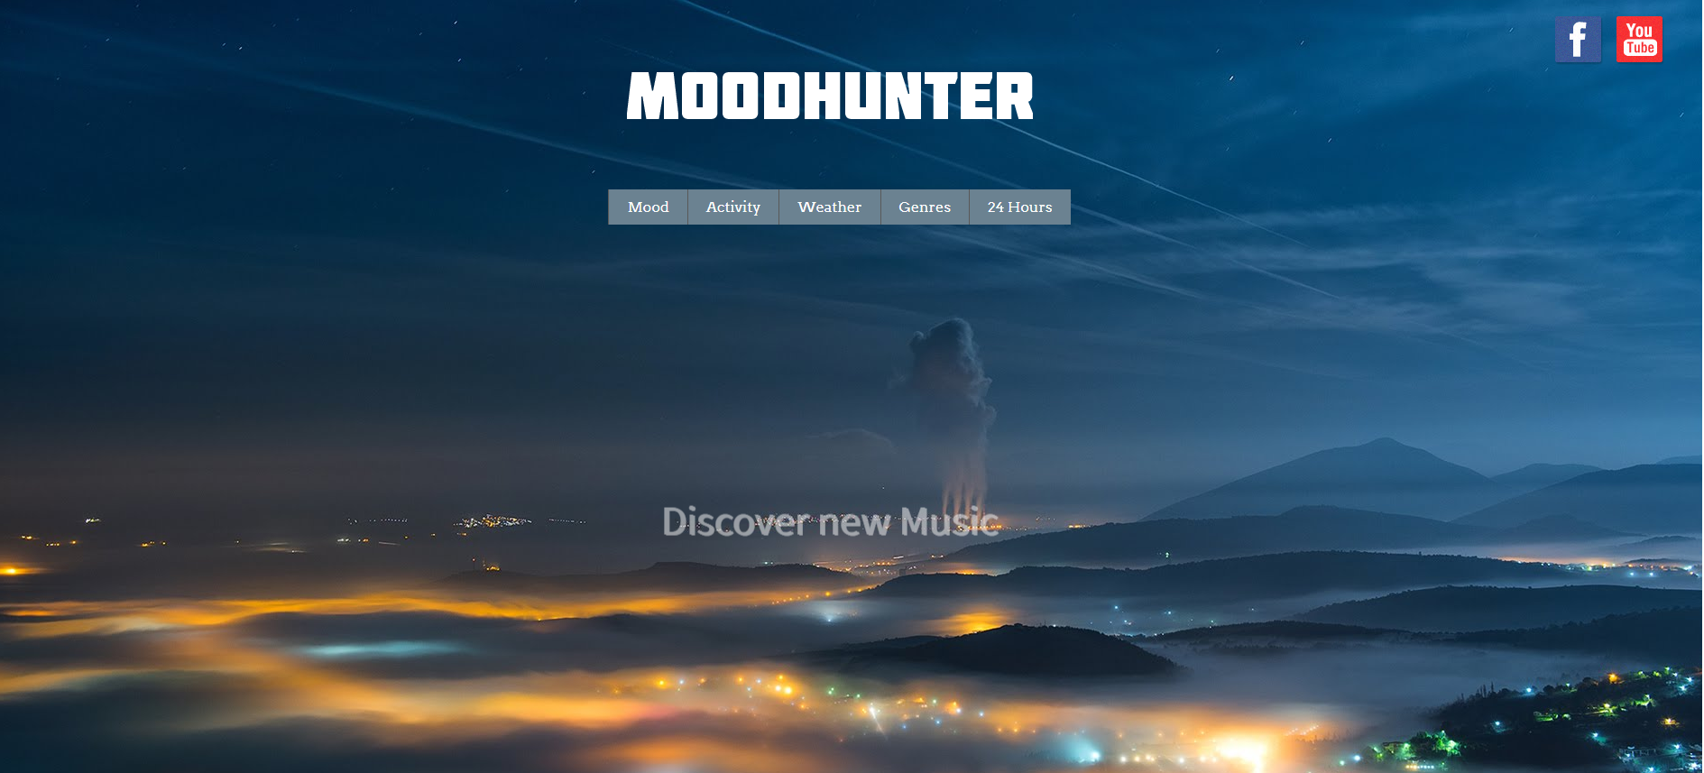

The basic function of MoodHunter is for users to listen to their ideal music. It’s easy for the user to navigate through the navigation bar or clicking on the images below so it guides them to the next page where you can see an image depending on what you have clicked. Below that you can find the playlist to press play as well as the Turn off Light button which makes the screen darker if the user would like to let the music play only for background without it being so bright.

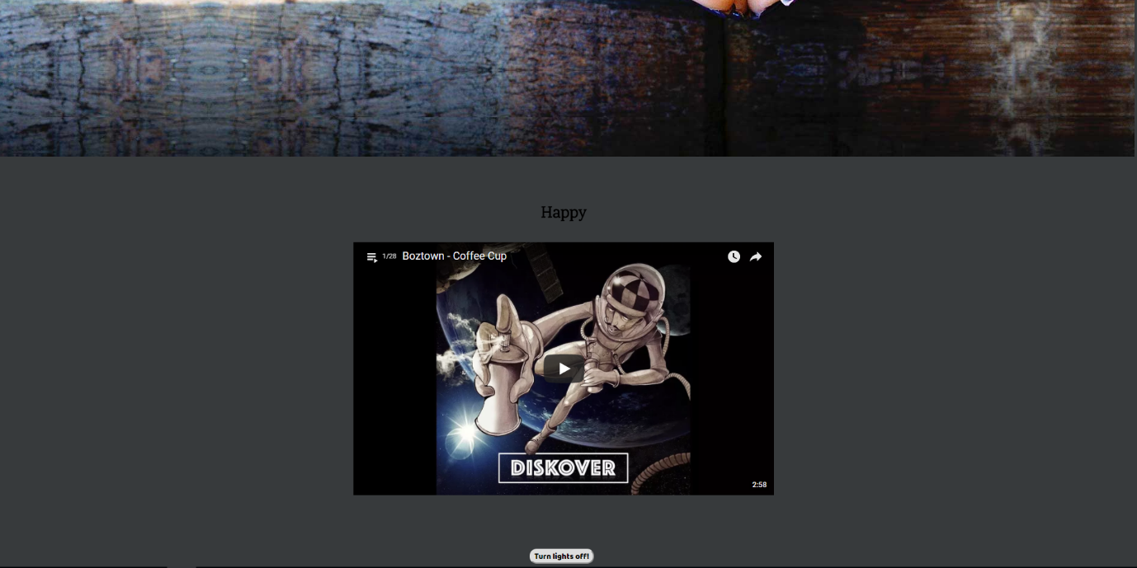

On the home page on the top left corner you can clearly see the Home and Contact Us links. Clicking on Home refreshes the page and by clicking on Contact Us, another screen appears. On that screen, if a user would like to contact they just have to insert their Name, Email, Phone number, type in their message and hit submit.

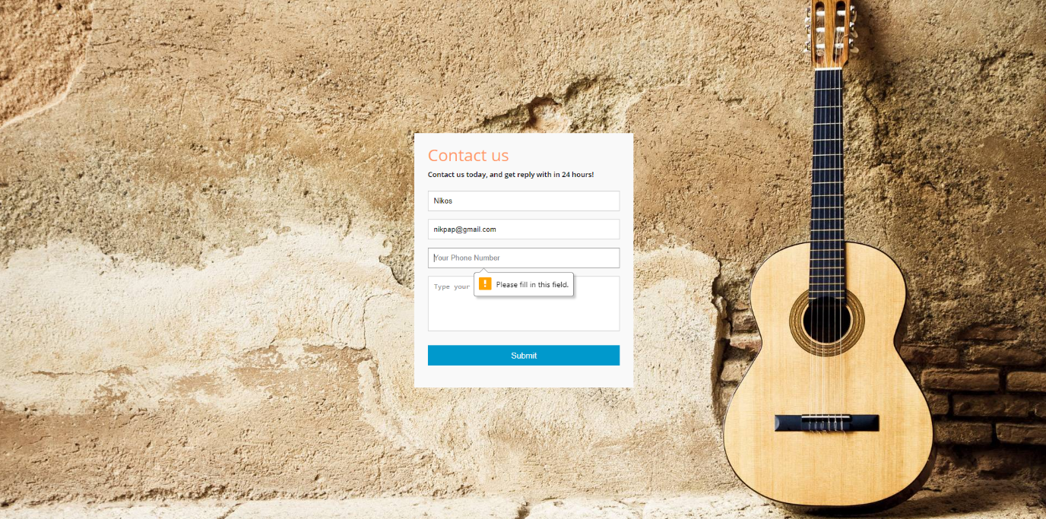

Another idea that had occurred to me is that on the screen, where the playlist is, when the user pauses the video that is playing each time, a pop-up message would appear that would say: “Taking a short break?” But in order to apply that, I had to get YouTube to agree with policies. Another improvement which I think would suit my website is to have several playlists for one “Mood” so users can choose and not listen to the same playlist all the time. I also had in mind to create a chat room next to the playlist so users could interact with each other, but then I had to create a Register/Log in page, which I did not want from the beginning.

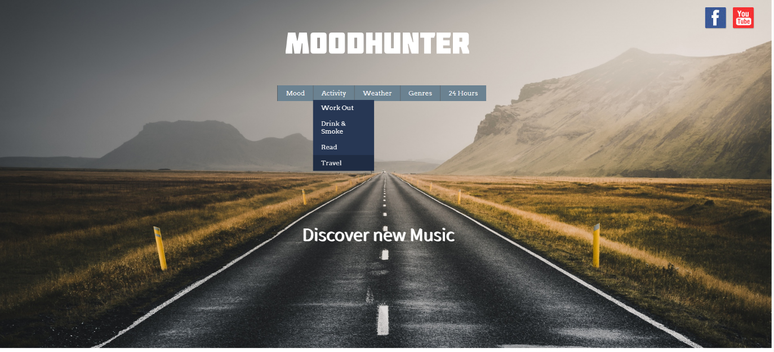

As far as visual design is concerned, it is my belief that the home page creates a first impression for the users that it is a music site. Emotions have a big influence on most of our decisions, by using specific images, fonts and colours we can affect the way people feel about the site. Creating my own logo instead of using text was an idea a friend gave me, and it looked way better. Employing animations such as the images shifting and fading every four seconds, hovering with the cursor over the scroll down element, gives positive feelings to the user and does not get boring. When I first started coding and designing the page I had GIF’s instead of images so the site looks more “dynamic”, but resizing them how I wanted was too difficult and as a final result by comparing the two, the image looked way better. Hovering over those images the border-radius and opacity modifies so it looks more “playful”. I am aware that contrast counts regarding several fonts on the site so I tried many and different Google fonts for the navigation bar until I found one that really appealed to me. I modified several fonts as well, for the text that animates when you click on a specific mood. Colours need to be consistent to deliver an aesthetic appeal, so I had in mind that the images on the slide on my Hope page to be mostly in black and white range.

In conclusion, learning how to code has been very interesting and I enjoyed all the sessions at the lab. I will do my best, building on the knowledge I already have so I can improve my site as I will be hosting it online when the time is right.

My Sources:

* Session materials
* CodePen.com
* Css-tricks.com
* Github.com
* YouTube videos
* W3schools.com